Annual Report
2013-14

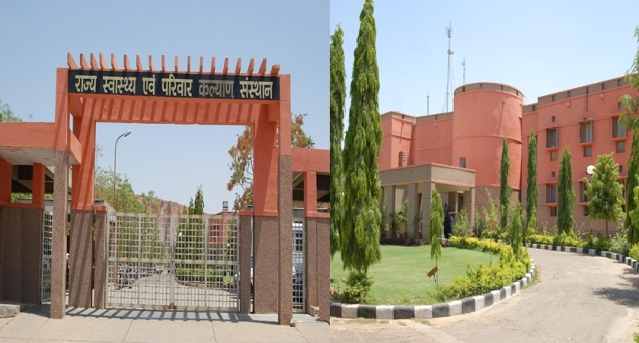

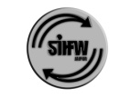

State Institute of Health & Family Welfare
Jhalana Institutional Area,
Near Doordarshan Kendra, Jaipur-302004
Rajasthan
Website: www.sihfwrajasthan.com
Email:sihfwraj@ymail.com
Phone: 0141 2701938
Telefax: 0141 2706534

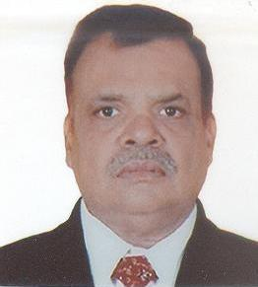
From the Desk of Director
Dr. M.L Jain
The institute completed another year of commitment towards research and development to support Public Health interventions of the State, in terms of Capacity Building, Research studies, monitoring and supportive supervision activities.
The Institute, through collaborations and Partnerships, functions with integrated approach, in lines with objectives of the National Health Mission and extends support to Directorate of Medical Health and Family Welfare Services, Rajasthan.
The institute's greatest strength is the passionate team and guidance of specialists from partner agencies and collaborating organizations.
Together, with NHM, the institute is contributing towards research and capacity building to improve health care services and improve health indicators thereby towards achievement of MDG goals.
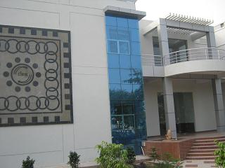
About SIHFW

State Institute of Health & Family Welfare (SIHFW), Rajasthan, was established at Jaipur by the Government of Rajasthan in 1995 as an apex level autonomous training institute. The institute was established to serve the State Health System in areas of capacity building and perform the role of a resource centre and a training institution to bring in uniformity of contents in all training programs. The training programs developed reflect capacity building and skill development needs and requirements of various cadre of workers and the institute also monitors the content delivery and quality aspects of training.

SIHFW is a collaborative training Institution for NIHFW (National Institute of Health and Family Welfare, New Delhi) and serves with support of Health & Family Welfare Training centers (at Jaipur and Ajmer), District Training Centres (DTC) and ANM Training Centres (ANMTCs).

SIHFW, Rajasthan is an ISO Certified institute in sector of Public Health, with infrastructure and manpower strength to support high training load within the institute and coordinate activities in periphery of districts/ blocks of the State.

Mission

State Institute of Health & Family Welfare, Rajasthan is committed for improvement in health care through HRD, Health Research, Consultancy and networking aiming at enhancement in the quality of life.

Thrust Areas  - Reproductive Health  - Neonatal and Child Health  - Maternal Health  - Adolescent Health  - Non-Communicable Diseases  - Nutrition | Capabilities  - Capacity Building  - Research on data analysis  - Survey Research  - Programme Monitoring  - Monitoring of training  - Supportive Supervision  - Documentation and Creative Writing  - Networking | Functions  - Training  - Research  - Monitoring  - Recruitments  - Consultancy  Documentation

Managerial Skill Development

Foundation Course for Newly Recruited Medical Officers
Aim of foundation course is to orient the newly recruited Medical Officers with Health System, National/State Health Programs & schemes, Management/ Administration aspects, Financial procedures & RSR, Conduct rules , Maternal & child health & Legislations and policies, Routine Immunization, NSSK, IYCF, RTI/STI, ARSH at SIHFW and 10 days hands-on training on BEmOC and PPIUCD at Medical colleges/District Hospitals. All seven approved batches have been implemented wherein 200 Medical Officers of the State have been trained. The hands-on training were organised at Medical College level Hospitals and District Hospitals of Chittorgarh and Churu. In 7 batches, 200 Medical Officers were trained.
As an outcome, the new MO gets acquainted with the basic principle of Administrative rules, financial procedure & technical skills to run the primary health center more efficiently.
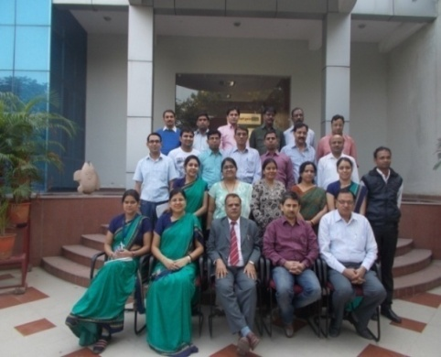
Professional Development Course (PDC)
PDC - A Success Story

…..I did'nt know that I could do a success camp on Maternal Health….when I did the training I had no idea to do something special which increased my confidence level. Some theoretical and practical learning was done during PDC course, hence it was planned to organise a health checking-camp for pregnant women, at each panchayat of my sector. All planning and resource pooling was planned by me, and I received support and contribution from administration and staff. After doing first camp at Sub-centre Ramganj Balaji, a mobile unit was developed. At DHS meeting, a presentation of the activity was done, which was appreciated. I am thankful to Dr. M.L. Jain, Director SIHFW and his team of Faculties and Training Coordinators at SIHFW, for coordinating the training in a manner which helped me plan the activity and implement it, making the training a successful experience…
Dr Vinod Sharma, MO/IC PHC Matunda, Bundi
Participated at 9th batch of PDC (Dec 18, 2013 to Feb 25, 2014)

Dr Vinod Sharma,
MO/IC PHC Matunda,
Bundi

The Professional Development Course for Management, Public Health & Health Sector Reforms for District Level Medical Officer funded by MOHFW is organised with an objective of training of middle level Medical Officers to enhance their effectiveness in their performance for service delivery. This integrated training incorporates management, public health ongoing reforms in the country including the NRHM in a ten weeks program. Middle level Medical officers with minimum five years in service and 5 years left in service. The course is financially supported by Ministry of Health and Family Welfare (MoHFW).
In three batches (VII to IX), 45 participants have completed this course during 2013-14.

Training of Staff under Programme Management Unit
These Staff trainings are organised for capacity building of district level managers and block level Mangers, which include Chief Medical and Health Officer, District Programme Managers, District Account Managers, Block Chief Medical Officers, Block Programme Managers and Block Accounts Managers.
Strengthening of the PMU staff with latest innovations and provide clarity for the field related problems

From the Block Units 335 and from State Unit. 26 participants have been trained. The training are organised at SIHFW.

Maternal Health
The EmOC Training Program
The overall objective of this training program is to develop capacity of doctors working in Government Sector in India to provide high quality emergency obstetric care services in underserved areas to prevent maternal mortality and morbidity.
Integrated EmOC Training of 126 days includes 112 days of EmOC and 2 weeks of CAC, Minilap, RTI/STI, IUCD and PPIUCD Trainings.
Eligibility criteria for undergoing EmOC training is MBBS doctors posted at CHCs/FRUs/DH who are in state government services for at least 5 years and should not have less than 10 years service left in the state services.
The training is organised at RNT Medical College, Udaipur and SMS Medical College, Zanana Hospital Jaipur. During financial year 2013-14, 30 participants were trained in 4 batches of Integrated training of MOs on EmOC.

The Refresher EmOC Training
The training is being conducted by SIHFW in order to certify the already EmOC trained Medical Officers whose certification is pending for the training conducted in 2007-08. The training duration is of 21 days, the first two weeks are utilized for hands-on skills and reorientation of EmOC services and final examination is conducted in the last week.
EmOC training is an attempt to increase number of qualified and skilled health care providers at Health facilities particularly below district level, hence the capacity building of these doctors will help in provision of EmOC services nearer to the people living at or below sub district level. Timely access to EmOC services will thus help in accelerating the decline in maternal mortality and morbidity. In three batches, 17 participants have been trained during 2013-14 in Refresher EmOC training.
Skilled Birth Attendant (SBA) Training for Ayush Medical Officers
During financial year 2013-14, SBA training has also been organized for Ayush MOs. 5 batches were organized and 48 participants have been trained.
Integrated training for Health workers (With SBA)
Aim of the Integrated training for Health workers (With SBA) is to train the health workers in various component of health like maternal health, child health and adolescent health through trainings on SBA, CAC, IMNCI, NSSK, RI, RTI-STI, IUCD &IYCF. ANMs, GNMs and LHVs participate in this training. There have been 80 batches wherein 837 participants were trained. The trainings are coordinated at District level training centres.
Skilled paramedic will be available during pregnancy, childbirth, and the postpartum/natal period, which is among the most critical interventions for improving maternal and neonatal survival.
ToT on SBA
The training was organised to train trainers -district level master trainers to further train health workers and provide them knowledge about SBA. Participants include Obs/Gyn Specialist, Pediatrician, Labor Room In-charge, Nursing Staff at Post Natal Ward and ANMTC/DTC Faculty.
During financial year 2013-14, 95 participants were trained in 5 batches. The trainings were done at SIHFW, Jaipur.
Comprehensive Abortion Care Training program
The training aims at imparting knowledge and skills development for Medical Termination of Pregnancy (MTP) services through Manual Vacuum Aspiration (MVA) and Medical Method of Abortion (MMA) at all level of facilities starting from Primary Health Centre to tertiary level. Obs/Gyn Specialist, Medical Officers and Nursing staff are trained on CAC. 158 participants have been trained under CAC. The batches have been conducted at District level hospitals and Centres of Medical College Hospitals.
ToTs on RTI-STI /IMEP / IYCF/NSSK
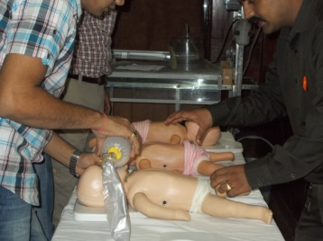
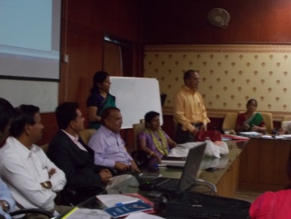
Aims to develop the team of district level district level master trainers which will further train the health workers and provide them knowledge about management of RTI-STI, IMEP, IYCF and NSSK.
Medical Officers, nursing Staff and ANMTC/DTC faculties are trained as ToTs.
RTI / STI –2 batches conducted and 24 participants trained, IMEP – 2 batches conducted 135 participants trained, NSSK -2 batches conducted 61 participants trained and IYCF- 1 batch conducted and 31 participants trained. The batches were conducted at SIHFW, Jaipur.
Training of Staff under Blood Storage Unit (BSU)
Training on management of Blood Storage Unit for the staffs posted at the BSU of the CHC/FRUs in the districts aims at training the MOs and LTs about management of Blood Bank at the respective facility. Medical Officers and Lab technicians are trained in this training programme. 58 participants were trained in 8 batches.
Training on Life Saving Anesthesia Skills (LSAS)
The purpose of the course is to provide the selected MBBS doctors with necessary skills and competencies to manage cases requiring life saving emergency obstetric care at the First Referral Units.

After undergoing the training course the trainees are expected to acquire skills in the following areas:
- Pre-anesthetic examination of patient (history, physical examination, systemic examination, interpretation of test results, deciding about the type of anesthesia which can be best given to the
patient, pre-anaesthetic preparation (physical, psychological, legal aspects like consent, drugs etc)
- Use of various types of anesthetic and support equipment usually required at FRU level, preparation of equipment before surgery and their maintenance and upkeep after surgery
- Resuscitation of new born and mother
- Perform laryngo-scopy and endo-tracheal intubation
- Administration of general anesthesia and regional anesthesia, their maintenance during surgery and management of patient during and after surgery

The MBBS doctors who have at least 5 years service and should not have less than 10 years service left in the State Services are eligible for this training.
The total duration of the course is 18 weeks (126 days). For 8 weeks trainees are trained in the obstetrics emergency in the operation theatre and for 4 weeks in general emergency. Then for 4 weeks the trainees work in the selected district hospital in their respective districts, under supervision of the supervisor.
8 batches have been completed in which 29 participants were trained at Medical College level Hospitals.

If LSAS trained doctors is deployed rationally, it would be possible to operationalise FRUs ,which were not functional due to shortage of specialist manpower, Anesthetist, particularly at district and sub district level and there will be effective and better management of Emergency Obstetric needs at the grassroot level.
Routine Immunization (R.I.)
These trainings are organised for Medical Officers and Health Workers.
- To explain the different factors that inform vaccine policy decisions
- Access current vaccine policy
- Describe the current vaccine schedule
- Describe how immunization programmes are monitored through the use of surveillance and the COVER programme
- Design appropriate schedules for individuals with uncertain or incomplete immunisation status
910 Medical Officers were trained in R.I training and 3899 Nursing staff were trained in RI. The training for medical officers is conducted at State level and for the health workers is organised at District level.
Child Health
Facility Based New Born Care (FBNC) Training for Nursing Staff
The overall objective of the training is to orient the participants towards the needs of the newborn care in the community and facility. It aims at educating the participants about the care of newborns in labour room, SNCU and in postnatal wards. The FBNC training also aims at educating the nursing staff and the MOs on the skills of newborn resuscitation.
The FBNC training is given to both the MOs and the nursing staff posted at the FBNC units of the respective district hospitals. The Duration of training (Classroom training) is 4 days. In the PIP for the year 2013-14, the training was only for nursing staff. Nursing staff posted at FBNC units of District Hospitals are trained at these training. The training batches have been held at RNT Medical College, Udaipur and JLN Medical College, Ajmer
Six batches have been completed and 118 participants have been trained across the state in these six batches.
Facility Based New Born Care (FBNC) Observership Training for MOs and Nursing Staff- Two Weeks duration
FBNC Observership training for MOs and Nursing staff is organized with a purpose of giving practical training to the staff posted in the FBNC units of the district hospitals. The 14 days observership training aims at giving practical exposure to participants on handling newborn care services, hand-washing practices, basics of new born care ward, resuscitation and other practices related to facility care of new borns.
The FBNC training is given to both the MOs and the nursing staff posted at the FBNC units of the respective district hospitals. The Duration of training (Classroom training) is 14 days. MOs and Nursing staff trained in 4 days FBNC training (class room training) are trained further in observership. The observership is organised at Kalawati Saran Children’s Home, New Delhi and King Edward Memorial Hospital, Mumbai.
Ten batches have been completed and 53 participants have been trained across the state in these ten batches.
Training on care of Severely Acute Malnourished (SAM) Children for Medical Officers
Training on care of SAM children for Medical Officers aims at management of SAM children to prevent the death due to malnourishment and to promote the community based treatment and counseling. MOs, Pediatricians posted at MTCs in the districts are trained in this training. 8 identified MTCs in the state which include all 7 Medical Colleges and District Hospital Chittorgarh are venue for the training. Two batches have been completed and16 participants have been trained across the state.
Training of MOs on F-IMNCI
Training on F-IMNCI aims at making the participants understand the management process of all sick newborn and children referred to a hospital and also carry out ETAT (Emergency Triage, Assessment and Treatment) of all sick young infants and children when they arrive at a health facility. MOs, Pediatricians posted at NBSUs in the districts undergo this training, organised at all 7 Medical colleges in Rajasthan. In one batch of training, 12 participants were trained.
Community Processes
Under important component of Community processes of NRHM, capacity building of ASHA Sahyogini is being done by SIHFW, for the first time. The details follow:

Training Programme for ASHA-Sahyogini

The objective of ASHA training is to develop capacity of ASHA Sahyogini to support NHM interventions in Rajasthan. Various training for ASHA Sahyogini are being organized in Rajasthan, by SIHFW.
Induction Training for ASHA
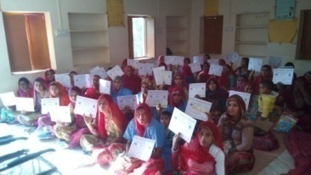
The eight days Induction training of new ASHA covers content of earlier five modules (Module1-5). The training inducts the newly selected ASHA about functioning and goals of NRHM and trains them about roles and responsibilities.
Module 5 Training
The training of Module 5 were conducted in the financial year 2014 only for completing the backlog of earlier years. This was a four day training and was implemented at District and Block level. This training helped ASHA in developing necessary skills which are required by her to perform better. However, Module 5 trainings are not to be done after the financial year 2014.
Module 6 & 7 (Round 1 and Round 2)
These trainings are to be implemented in four round of 5 days each, with an interval of about two-three months. The training is based on key competencies in maternal, new born, child health and nutrition. The training aims at developing necessary technical skills of ASHA sahyogini in order to contribute to HBNC and other health care services.

During 2013-14, in total 1588 batches were completed, which is 75% of the targets.

ToT for Training of ASHA trainers
For implementation of trainings at District level, Training of Trainers was done at State level. Two batches were organised for Trainers including RCHOs and District ASHA Coordinators. In two batches 60- trainers were developed.

Refresher Trainings for ASHA Facilitators

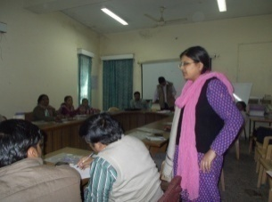
Refresher trainings of 5 days duration were conducted for ASHA facilitators. Trainings were implemented at District level. The training was based on ASHA Facilitators Handbook. Participants include ASHA Facilitators/ supervisors/ PHC supervisors/ health supervisors. The training was organised to train ASHA facilitators in skills of problem solving and assisting ASHA sahyogini and to refresh the monitoring and supervisory skills of ASHA facilitators. 20 batches were completed.

ASHA ToT for NIPI Districts
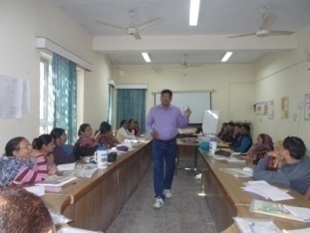
Training of Trainers were organised for NIPI Districts-Alwar, Bharatpur and Dausa. There were no ASHA trainings being done in these districts and there were no ASHA trainers in these districts. For the first time, District Training teams were developed for initiation of ASHA training in these districts. Three Batches of Five days each. Training was organised at HFWTC Ajmer.
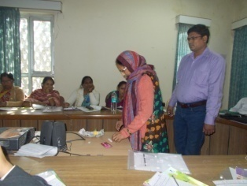
The training is implemented to develop training skills for training ASHA sahyogini in Module 6 and 7 for Round One and Two. In three batches, 92 trainers have been developed.

Orientation of State Trainers

For planning and implementing above ToTs for NIPI Districts, two Orientations were organised for State Trainers on December 9, 2013 and December 15, 2013 at SIHFW.
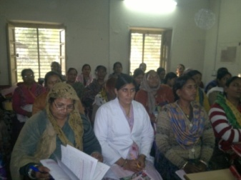
Need based Training of Trainers (Round One ToT)
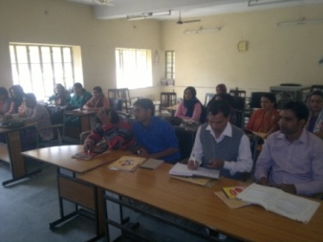
Seven days ToTs were organised at Rajasmand and Bhilwara to develop District Training Teams for ASHA training on Module 6 and 7 (Round One and Two). The training batches were conducted to reduce the gap between required and available trainers for achieving targets of ASHA trainings. In two batches, 31 trainers have been developed.

Review cum Orientation Meetings for ASHA Training
- Organised on 6 June, 2013: The Meeting was organised under chairmanship of Director RCH cum Director SIHFW, at DMHS. There were 11 participants.
- Organised on 17 September, 2013 at SIHFW. There were 72 participants.
- Organised during 5-7 February, 2014. 30 Participants were present at this meeting.

Academics
Contact Program Classes
SIHFW is a centre for contact program classes in distance course of one year Diploma course in Hospital Management. The course is run by National Institute of Health and Family Welfare. SIHFW faculties and subject matter specialists deliver interactive lectures and doubt clearing sessions in classrooms.
The first batch of the contact program classes at SIHFW was held in the month of December, 2013, for academic year 2013-14. Twenty three students enrolled in the course have attended the classes at SIHFW.
Projects and Research
Improving Maternal and New Born Survival in the State with Special Focus on 4 HPDs
UNICEF and SIHFW are working together in most of these areas with UNICEF providing technical and financial support when required. To further streamline this partnership with the objective of achieving and facilitating for expediting the process of achieving results, UNICEF and SIHFW has entered into a long term partnership for improving Maternal and New Born Survival in the State with Special Focus on 4 HPDs with the following objective:
- To set up mechanism for facility based onsite mentoring and document changes in quality of services provided through the selected delivery points.
- To conduct various assessments/ evaluations as and when needed particularly of the innovative approaches in the state including Capacity Building Initiatives for Maternal Health, Newborn and Child Health and Immunisation
- To build capacity of service providers and managers from 4 High Priority districts on programme management and data management.
- To set up a mechanism for supportive supervision for Home Based Newborn care and Child care in 4 High Priority Districts
- Documentation of innovative approaches and develop manuals for their state wide scale up.

Total 4 themes were identified for which the identified mentors were trained so that they can further deliver hands-on training for identified facility staff.
Each team consist of 3 member- 1 MO, 1 NT/PHN and 1 NS
3 types of formats are to be filled by each team along with giving training
- Facility Assessment
- Passbook
- GoI checklist
Theme 1 | Resuscitation and new born care
Theme 2 | Intra partum Care
Theme 3 | Care of sick new born
Theme 4 | Infection Prevention
Theme 5 | ToT on PPTCT
Theme 6 | Appreciative inquiry- Discovery

The mentoring visits were introduced with the purpose of giving in situ training to the staff posted in labour rooms of delivery points; they otherwise do not get regular training on the pretext that the work might suffer. Mentoring visits were planned in such a way that on a pre decided date, staff posted at the delivery point and their Sub Center staff participated in the training. Hands on or demonstration was given in the Labour room followed by theory session.

Training of Trainers on Themes 1, 2, 3 and 4
The ToTs were organised during November 2013 and December 2013 and January, February and March 2014 at SIHFW.

ToT on Supportive Supervision
6 Frontline supervisors (LHV and PHS) from each of the districts Banswara, Barmer, Dungarpur, Jalore were identified and trained at SIHFW on effective supportive Supervision. Participants were briefed about RMNCH Plus A programme and their role as a supervisor for ASHA. Participants learned about various social norms contributing to neonatal, infant and maternal mortality.
Review Meeting
After the mentoring visits of Theme 1, 2 and 3, a review meeting was organised at SIHFW of mentors and the facility in-charges of facilities where mentoring was done. Sh. Neeraj K.Pawan, AMD chaired the review of Banswara and Barmer districts and appreciated the achievements of each of the team. Sh. Sunil Dhariwal MD- NRHM chaired the review meeting for Jalore and Dungarpur Districts.
This initiative of mentoring visit was appreciated by AMD, NHRM and MD, NRHM and further decided to scale it to other facilities in the state.
CBI-RI initiative Assessment
SIHFW coordinated the rapid assessment for Partnership on Capacity Building Initiative -Routine Immunization in Rajasthan. The partnership was done between CDC Atlanta, UNICEF and GoR to implement Capacitive Building Initiative – Routine Immunization in Rajasthan. Under this partnership , Ms. Laura, Ms. Alice Pope from CDC Atlanta and Dr. Manisha Chawala, Health officer from UNICEF supervised and organised the rapid assessment activity. .
Tools developed were piloted and after finalization of tools, SIHFW staff was orientated on tools for the assessment. Total 14 districts were covered under the assessment including Bharatpur, Karauli, Jalore, Rajsamand, Sirohi, Banswara, Baran, Jhalawar, Jhunjhunu, Bikaner, Sriganganagar, Jaipur-II, Ajmer and Tonk.
Still Birth Review Mechanism
Draft of tool were prepared by UNICEF team and the same were shared with the LR and SNCU in-charge doctors and nursing in-charges of the identified 6 facilities i.e DH Jalore, DH Banswara, DH Dungarpur, DH Barmer, SDH Sagwara and SDH Balotra. Importance of need to address the still birth and perinatal death review was discussed. Identification of a still birth as per GOI norms was discussed along with a factual representation of the new born deaths in India. The tools were discussed and modified as per the discussion with the participants. The tools were tested at CHC Sanganer. Director RCH and Director SIHFW addressed the participants and emphasized on the need to address the issue.
Formats were distributed to the participants for their facilities and were asked to pilot it for next 15-20 days and send us the report of still birth review and perinatal death review.
Job-aids for Field functionaries
Job aids in form of posters and story booklets were developed for the front line workers, such as ANM, ASHA and Anganwari workers. The job aids are being developed in partnership with Save the Children, Jaipur. The Job aids were field tested before finalization. The Job-aids were developed for strengthening of MCHN services of the state on following areas-

- God Baharai
- Annaprashan
- MCHN Day
- Weight measurement
- ANC

COTPA- Compliance Assessment Survey-Jaipur

A survey research was done for Jaipur district. This was a Compliance assessment survey on prohibition of smoking in public places rules, 2008 under COTPA in Jaipur city. The major objective of the study is to assess the current level of compliance to section 4 of COTPA in Jaipur city & assess the preparedness of Jaipur city for declaring it as a smoke free city. Individual surveys have been done at sites such as Hotels, Restaurants and places where food and drink can be purchased (including surrounding open spaces containing refreshment rooms, banquet halls, discotheques, canteens, coffee houses, pubs, bars and airport lounges),Workplaces, Shopping malls, Markets, Cinema Halls, Educational Institutions and Libraries, Hospitals, Auditoriums, open auditoriums, amusement centers, stadiums, Railway stations, bus stops, etc.
Role of Private sector in Family Planning Program
SIHFW implemented a rapid assessment study titled as “Role of Private Sector in Family Planning Programme in Rajasthan.” The study was conducted in selected districts –Ajmer, Bikaner, Jaipur, Kota and Udaipur, to identify the involvement/ contribution of private sector in provision of the family planning services.

Semi structured questionnaires have been used in the study for collection of primary data and secondary data was collected from previous studies and records available with the funding partners-UNFPA. Source of information were Hospitals, NGOs, Social Marketing agencies and Outlet centres.

Monitoring

All trainings coordinated at District or Block levels are monitored by SIHFW staff. This is an ascribed activity and is being carried out in routine. The monitoring visits are made for hand-holding and ensuring quality of trainings. The observations are recorded in Monitoring formats for each training.

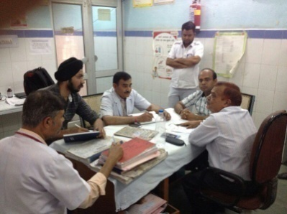
Block Monitoring
SIHFW has extended its hand to further support Government of Rajasthan and UNICEF in their efforts of improving services. Each month 4 blocks are randomly picked in which one FRU, one PHC/non FRU, one SC and 2-3 households are covered.
Facilities are assessed on the basis of infrastructure and services. Staff is assessed on service delivery and skills. Household are randomly covered to understand the services availing by population of catchment area.
Block monitoring activity is done by SIHFW in each High Priority District of UNICEF. These districts are Jalore, Barmer, Dungarpur and Banswara. District Hospitals, CHCs, PHCs and Sub Centres of these districts are visited for supportive supervision. The lacunae identified are rectified immediately through skill up-gradation, resource planning, and recommendations. After the visit, the observations are briefed to CMHO, RCHO and other district and block functionaries for further decision making. This exercise also includes verifying the utilization records of hospital staff and facilities reports through community interaction and feedbacks on services availed.

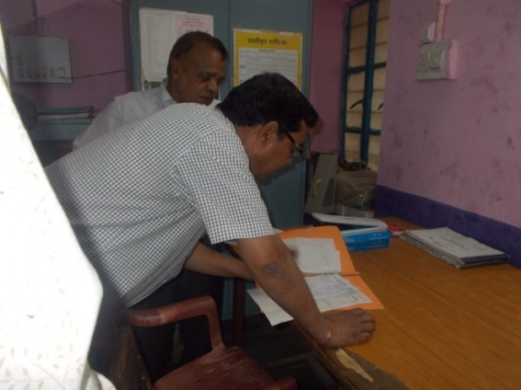
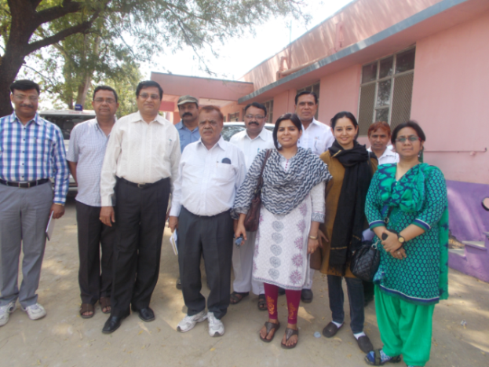

After returning from districts, there is a post-visit de-briefing session organised at SIHFW under chairmanship of Dr.M.L.Jain, Director SIHFW.

RCH Monitoring
The RCH /CTI staff at SIHFW is instrumental in Monitoring and evaluation of RCH trainings / other health activities, ensuring they are implemented as planned and also to assess whether desired results are being achieved.
The planning phase of trainings which involves nominations, correspondence with state and district officials, issuing training orders, development of monitoring plan, conduct field visits and lastly the submission of reports to Director SIHFW and NIHFW with Feedback and suggestions.
RCH team also ensures functional linkages between RCH /NRHM/NIHFW and SIHFW. The training load is calculated and action plans are prepared for trainings for getting them included under PIP of the state.
The Monitoring done by RCH consultants mainly focuses on the following
- Providing concurrent feedback on the progress of activities conducted by SIHFW
- Identification of the problems in the implementation of norms and Guidelines
- Initiate steps to implement corrective action on site.
- Identify large adverse variances both in terms of physical targets as well as expenditure
- Understand reasons for variances and Identification of corrective action to be taken.
- Making sure all the financial norms all followed in making payment and also ensure the SoEs and UC are received on time.
- Updating the records of all the trainings/trainees/Trainers/and training institutes in the state.
- Monthly updating the Master trainers list of various training and updating list of trained participants in various training.
HBNC+ Monitoring
Monitoring of HBNC+ training implemented by NIPI are being monitored by SIHFW since, January, 2014. This is being done by SIHFW staff and external monitors. This activity is being done in blocks levels of NIPI districts of Alwar, Bharatpur and Dausa.

Consultations and Workshops
Orientation cum Review Workshop - District ASHA Coordinators
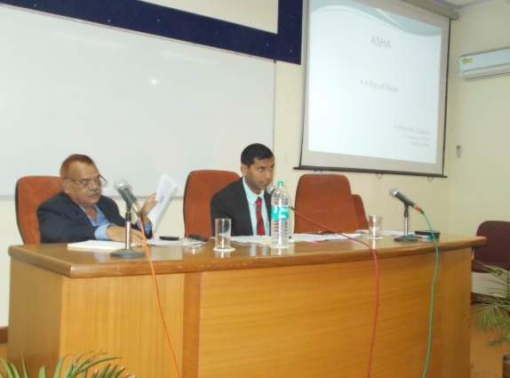
A three day review cum orientation of district ASHA coordinators was organised by NRHM during February 5-7, 2014 at SIHFW. The orientation was chaired by Shri Neeraj K. Pawan, Additional Mission Director, NRHM.

A presentation on ASHA Training Status was made by Dr. M.L. Jain, Director-SIHFW followed by a brief discussion facilitated by Dr. Mamta Chauhan, Faculty and ASHA Training Mentor at SIHFW, on training related issues of districts. The districts also shared their training calendar and progress updates for ASHA training.

Workshops on Delivery points
A series of workshops on Strengthening of Delivery Points of the State (District Hospital, Community health centres, Primary health centres and Sub-Centres) are being organised by SIHFW. Till March 2014 two workshops have been organised at Udaipur and Jaisalmer. There were sessions on orientation for delivery points, definition, list and analysis of the delivery points. Staff of the delivery points participated at the workshops. The workshops are planned to be organised at other HPDs also.

Workshop on Perinatal Death Audit

A workshop on perinatal death audit was held at SIHFW in March, 2014. The workshop was done in partnership with UNICEF. Pediatricians, Gynecologists and Nurse In-charges of Labour Room and SNCU, posted at 6 delivery points participated at the workshop. To simplify the system and formats for conducting perinatal death audits in the local context, which can generate information and evidence for perinatal death audits to facilitate programmatic and policy level decisions. Modified tools were shared with the participants for utilization at the facility level.

Capacity Building of SIHFW Staff

State Training of Trainers -ASHA
Mr Hemant and Mr Ejaz Khan of SHIFW were trained at ASHA Training of Trainers at National Site. The training was organised at Garchiroli, Maharastra during the month of March, 2014. The SIHFW staff members have successfully qualified the training and are now eligible to train ASHA sahyogini in module 6 and 7 (Round One and Two).

Orientation on Community Processes at NHSRC
Dr Mamta Chauhan, Ms Richa and Ms Archana received an orientation on Community processes at National Health System Resource Centre, New Delhi.

Capacity Building by UNICEF

All SIHFW staff participated at a Capacity building programme organised by UNICEF. The activity was organised under chairmanship and guidance of Dr.M.L. Jain, Director, SIHFW. There were learning sessions on Overview of MMR, IMR. Demonstration and hands-on skills development was done on use of ASSAN software for data representation and interpretation.
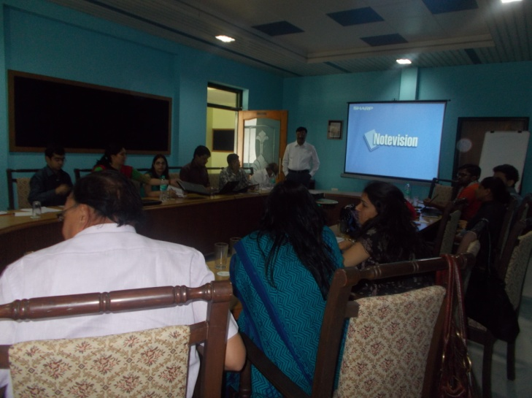
The activity was combined with field visits to Dungarpur and Banswara districts for supportive supervision.
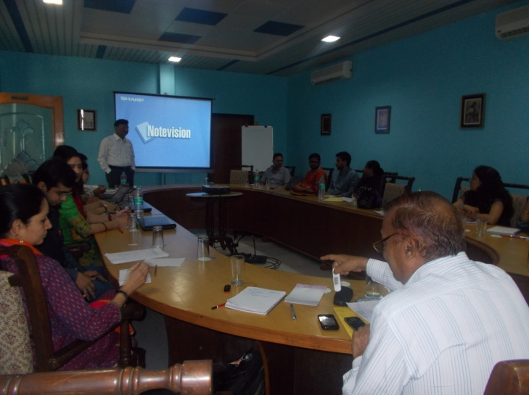

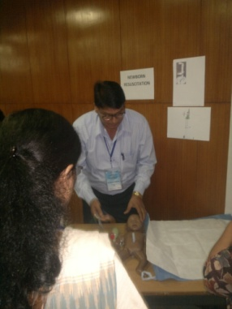
Workshop on Competency Assessment for strengthening competencies of Health Care Providers
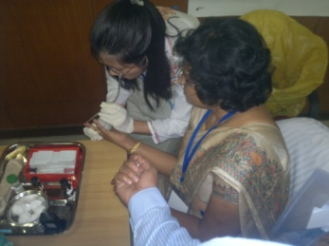
Mr Aseem Malawat of SIHFW participated at workshop on Competency Assessment for strengthening competencies of Health Care Providers on RMNCH+A Service, during 28 to 29 October, 2013. The workshop was organised by NIHFW.

Talk on Health Information Management

Dr Richa Chaturvedy delivered talks on ‘In-service training course on Health Information Management for Non-medical personnel’ during 22 to 26 July 2913 at CBHI, Jaipur.

The sessions were on Major public Health problems, National Health programmes and Visions & Goals of NRHM in India, Health Care Delivery and Health Information System from Peripheral to National levels in India and its management and Concept of Monitoring & Evaluation of Health Programme and Health Sector Related Millennium Development Goals.

National Communication Workshop on RMNCH+A

Dr. Vishal Singh, Faculty, SIHFW participated at the national workshop on RMNCH+A during March 13-14 at Bhubaneswar, Odisha. It was organised by UNICEF.

Counseling of Mothers of Severe Acute Malnourished (SAM) children

Training of Trainers on Counselling of mothers of SAM children at MTC was held at Udaipur in March, 2014. Dr Mamta Chauhan, Dr Richa Chaturvedy, Ms Aditi Sharma and Mr Aseem Malawat from SIHFW were trained in this training.

The training objectives were to improve the skills of master trainers on Interpersonal Communication and use of Information, Education and Communication (IEC) to further train the paramedical staff at MTCs, improving understanding about the importance of counselling of mothers on appropriate feeding practices for SAM children and to enhance and develop a common pool of knowledge through the available participants from varied fields and disciplines.

Training on Leadership Development

Dr.Sanjaya Saxena & Dr.Mamta Chauhan participated at a three days training programme Training Programme on 'Administrative Leadership in Government' 12-14 November 2013 at HCM RIPA Jaipur.
Workshop on Gender Budgeting
Ms Aditi Sharma of SIHFW attended a three days workshop on Gender Budgeting during April 2-4, 2013 at NIHFW, New Delhi.

MDP on Management and Leadership

Dr Mamta Chauhan participated at the Management development Programme on ‘Management and Leadership’ at Goa. The programme was organised by International Union against Tuberculosis and Lung disease. It was a national level programme.

Training on Project Management

Dr. Mamta Chauhan and Dr Bhumika Talwar attended a course on Project Management during 3-7 June 2014 at Hyderabad. This course was a part of a series financed by Bloomberg Philantropies. The course was organised by International Union Against Tuberculosis and Lung Disease.

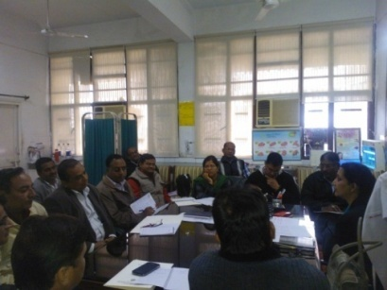
Exposure Visits

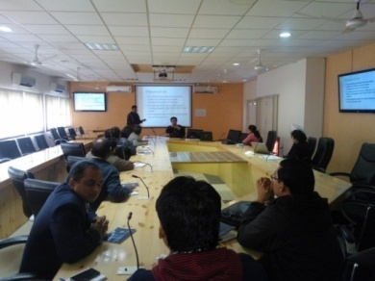
PDC Study tours
Participants of the Professional Development Course (XI batch) visited Panchkula during February 10 to 15, 2014. This was an Inter-State Exposure visit envisaged under the PDC course curriculum. The tour was made under guidance of SIHFW coordinators Mr Ravi Garg and Mr Suneel Kumar Patel.

The team visited General Hospital of Panchkula. Participants met the Nodal Officer of DEIS (District Early Intervention System) and collected information of the same.

The IX batch of PDC was held at SIHFW from December 18, 2013 to February 25, 2014.

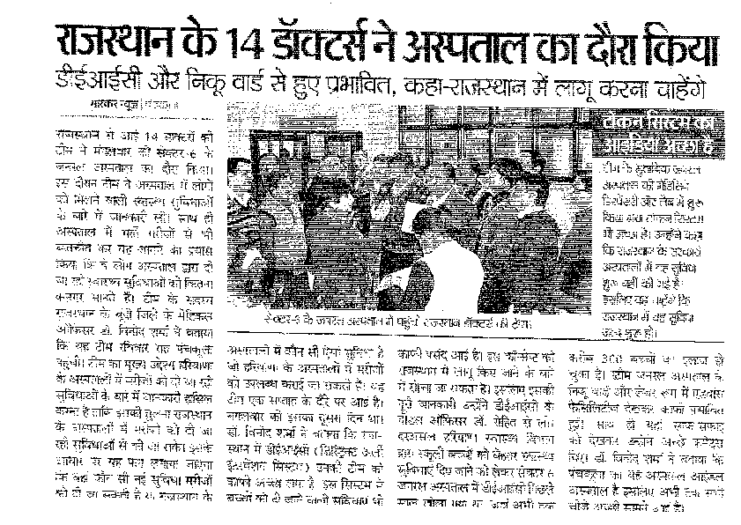The team of PDC participants visited National Institute of Health and Family Welfare (NIHFW), New Delhi under guidance of tour Coordinators from SIHFW-Mr Ravi Garg and Mr Aseem Malawat. The participants visited Jai Prakash Narayan Trauma Centre based at AIIMS, NGO-NAAG Foundation and attended sessions at NIHFW training hall.

Team of Professional Development Course (VIII batch), with Visit Coordinators Dr Vishal Singh and Mr Ravi Garg, visited Panchkula, Haryana during 21-26 October, 2013.

During the visit, team visited General Hospital Panchkula, District hospital, DTC and DPMU of Kurukshetra, CHC Kala and PHC Pinjaur. There were observations on innovative interventions and sessions on Pre-school Health education, Cure of club foot, NABH, Supportive supervision, Referral transport, Training Management Information System and Organogram of Haryana Health Systems.

Shimla, Himachal Pradesh
Participants of the VII batch of Professional Development course visited Shimla, Himachal Pradesh during 10 to 14 June 2013, with SIHFW facilitators Ms Archana and Mr Prathvi Singh. This was the second Inter-State exposure visit of the 70 days course, in process at SIHFW. The visit was hosted by SHFWTC Parimahal Shimla, under leadership of Dr Santlal Sharma, Principal, SHFWTC and Dr Anjali Chauhan, Faculty, SHFWTC. Participants visited IGMC at Shimla, Kamla Nehru State Hospital, PHC Mashobra, Sub Centre Baldeyan and Anganwari Centre Saun.

PDC Visit to Indore

Participants of PDC VII Batch visited RHFWTC, Indore, Madhya Pradesh during May 20-25, 2013. This was an important activity under Professional Development Course going on at SIHFW during 25 April to 3 July 2013. A team of 15 members including PDC participants and SIHFW facilitators visited Indore in this visit.

The purpose of the visit was to know the various innovations of other state governments introduced in the health sector and observation of functioning of the same.

The institutions visited included M Y Hospital, Indore, CHC Sanwar, Dewas, Killor Khurd and Sub Centre Tillor.

During the visit, participants were divided in sub groups of 3-4 participant each group for making observations on specific topic assigned to the group. These topics were – Quality Control and Manpower, Physical Infrastructure and Services available at facilities.
After returning from the visit, each group made presentations on the observations and learning of the Exposure Visit, in a session chaired by Dr Sanjaya Saxena, Registrar-SIHFW, and Dr Mamta Chauhan and Dr Vishal Singh, faculties, SIHFW.

Exposure visit to Chittorgarh SNCU
SNCU teams of Banswara, Sagwara and Dungarpur were moved to SNCU Chittorgarh. Each team had SNCU I/c Doctor, SNCU I/C Nurse, LR I/C Nurse, DEO of SNCU and Class IV. Team were taken on a round of SNCU Chittorgarh. The visit was observed by Dr. M.L.Jain, Director SIHFW and Dr. Girish Dwivedi, PD- CH. Dr. Jai Singh was the resource person for the overall exposure visit as he is managing the SNCU. Each cadre of participant was made to sit with respective staff of same cadre of SNCU Chittorgarh.
Exposure Visit to Patna
UNFPA in partnership with DMH&FW supported College of Nursing, Jaipur to organize a State nodal Centre. Under this initiative an exposure visit to Patna was made. A team of UNFPA representatives and faculties of the College of Nursing and Dr Vishal Singh of SIHFW went for the Exposure visit with an objective to understand and study Skill Lab, models and equipment required for establishment of the State Nodal Centre, during December 17-24, 2013.

Recognition and Awards
The organization has been awarded ISO 9001:2008 by the BSCIC.
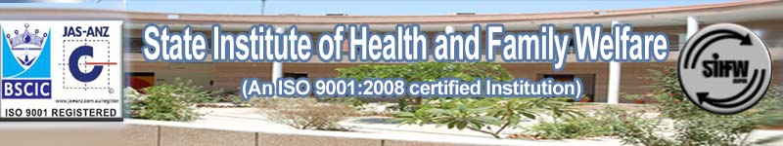

Training Arrangements
Training Halls
The Institute has a state of the art premises with four Training Halls and two Board Rooms for meetings and discussions.
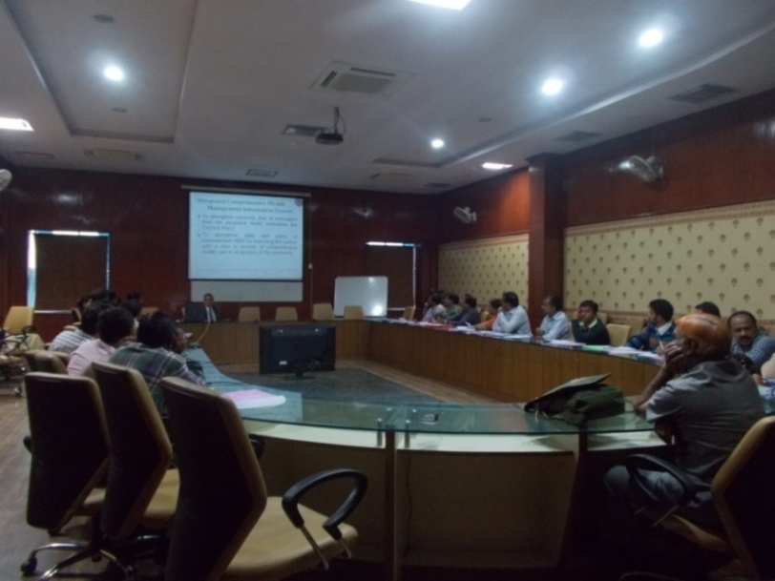

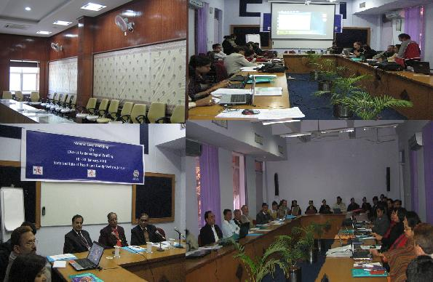

Training Halls at SIHFW
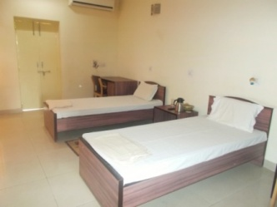

Hostel

The Institute has a Hostel facility to accommodate about 60-70 participants in dual sharing Air-conditioned rooms and furnished Guest Houses.

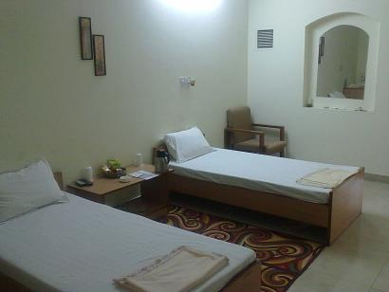
During 2013-14, about 2526 participants and guests stayed in the hostel including District Collectors and Superintendents of Police, eminent speakers from various institute of the country, students, NGO representatives and guests of other departments such as ICDS, RGAM, etc. Demand for SIHFW hostel facility is so high that dire need of constructing more rooms is being felt.

The Twin-Sharing Rooms

Cafeteria
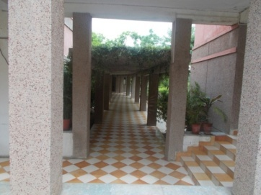
The Canteen serves hygienic four time meals. Arrangements for formal gatherings of SIHFW, celebrations and working High tea are also done therein. The services have been outsourced to provide meals on very nominal rates.
Way to Cafeteria

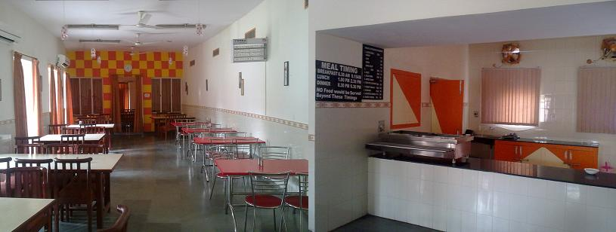

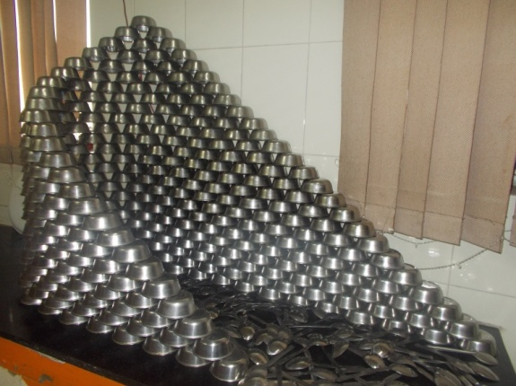

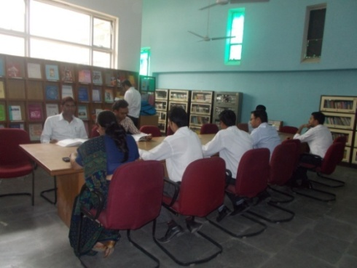
Library
Rich reading environment with books and documents of recognized authors and agencies, from across the borders. Books and other reading material is present from diverse fields ranging from Public health to personal development and management.

The reading tables

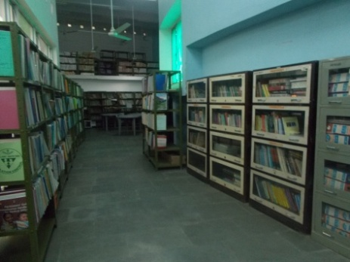
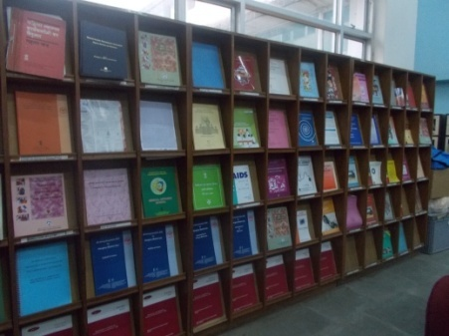

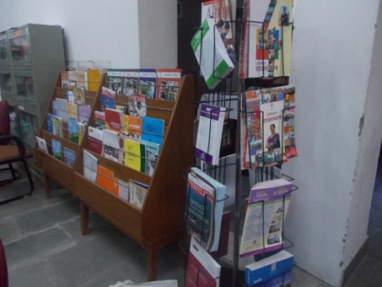

Display and Book shelves

Computer Lab

A Laboratory cum Computer Room with set up of 22 computers, for computer based and data management training programs.

Classes of Basic Computer Knowledge are also held herein under Professional Development Course.

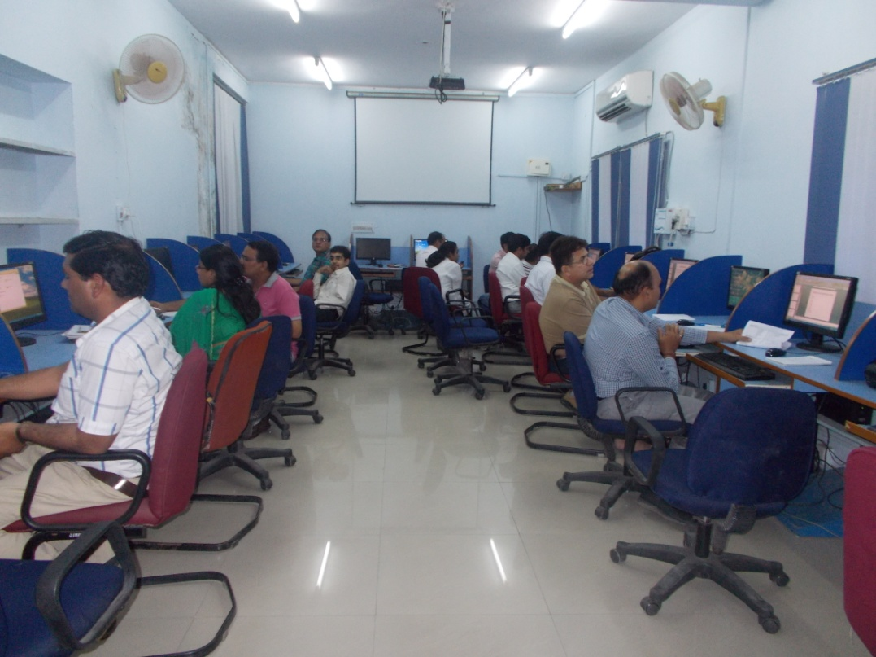

Skill-Station-The Computer Lab

Trainees' Feedbacks

1. Way of teaching was very practical and it included very basics.
2. The method of teaching and discussing was liked the most.
3. The information given by trainers is very useful.
4. Detailed explanation was given on every topic in simple language.
5. The training will definitely help me to execute and implement my knowledge in more effectively and practically.
6. Training and good behaviour of teachers.
7. Interactive sessions and field visits.
8. Teaching faculties and their way of communication is appreciable.
9. Healthy conversation between everyone.
10. Sessions were two-way communication and did not feel as a lecture only.
11. Way of imparting knowledge, friendly hospitability and good services.
12. Teaching and demonstration by the trainers with appropriate examples.

Visitor's Feedback
Excellent arrangements provided by the institute for conducting the workshop. Staff is also very cooperative.
Dr Uma Kapoor
Stay arrangements and food is good
Shri Lalit Kumar Gupta (District Collector Jhalawar)

The rooms are functional and good. Service is warm and hospitable. Would like to especially appreciate the staff for their helpfulness.
Ms Arti Dogra (District Collector Bikaner)

Thankyou for a very comfortable stay.
Dr Gauri Trivedi, Deepak Foundation, Gujarat

Very good amenities, courteous and helpful staff. Thankyou
Dr. Nandini Srivastava, Deepak Foundation, Gujarat

It is a good organization …we join our hands for tough war against Malnutrition.
Mr Dipankar Mukherjee, UNICEF

A very nice organization and very helpful people.
Ms Molshree Rathore, UNICEF

HTTP Link : table of Training Progress :2013-14
http://sihfwrajasthan.com/Sihfw Training(T) 13-14.html

